**Tripwire Axon Agent Install Procedure**

IMPORTANT: Before install this Axon (non-java) agent, do a telnet 10.104.28.17 5670 from an administrator command prompt on the device you’re preparing to install Tripwire. If the port is open, install this agent. If the port is not open, install the (java) TE agent. Also, **do not** install this agent on domain controllers.

1. Uninstall existing Tripwire agent  
   You will receive 3 pop-ups during the uninstall
   1. Pop-up1: Are you sure you want to uninstall? YES.
   2. Pop-up2: Do you want to run this...? Click Run. I did not capture this screenshot sorry.
   3. If you’re prompted for a passphrase instead of login prompt, go to step 2.
   4. Pop-up3: “…a reboot will be required…” -Click OK. (A REBOOT WILL NOT BE NEEDED)  
      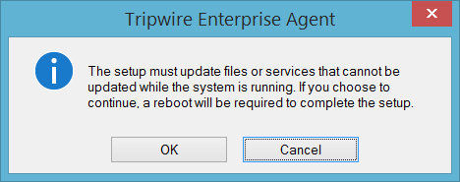
2. Run axon agent MSI for your OS:  
   The latest installs are located at: T:\data processing\Information Security\Tripwire\Axon  
   **Options**: Windows or Linux/Unix. This will not get pushed to AIX.  
   1. Install pop up - click Run  
      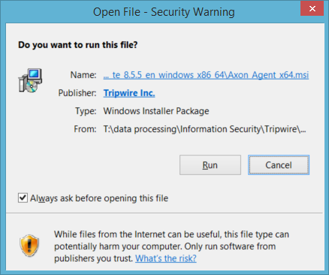
3. After the install MSI completes, place adjusted CONF file attached here and restart the TW services. Then check the Tripwire console.  
   1. COPY twagent.conf file (copied in this doc just below or use the link)  
      FROM = T:\data processing\Information Security\Tripwire\Axon

TO = C:\ProgramData\Tripwire\agent\config  


* 1. Stop and restart the Tripwire services from Task Manager